Power Shell 101
Module 2 Hands-on Activity – PowerShell in VSCode
4/20/2019 Developed by Sion Yoon
4/20/2019 Tested by Sam Chung
Center for Information Assurance (CIAE) at City University of Seattle

Learning Outcomes
- Learn about cmdlet, alias, and PSDrives in PowerShell.
- Learn how to map a new PSDrive

Resources
- Cmdlet Overview
https://docs.microsoft.com/en-us/powershell/developer/cmdlet/cmdlet-overview
- About Providers
https://docs.microsoft.com/en-us/powershell/module/microsoft.powershell.core/about/about_providers?view=powershell-6
- https://www.youtube.com/watch?v=_AiTBoH4IwA

Activities
- Using cmdlet
- Using alias
- Mapping PSDrives
- Q&A

Cmdlet
- Open PowerShell in VSCode

- Cmdlets are lightweight PowerShell scripts that perform a single function. PowerShell uses a verb-noun name pair to name cmdlets. For example, type “get-location”
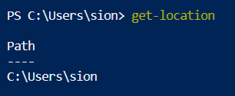

- “get-help” can be used to learn more about the command. To learn about the get-location cmdlet, type “get-help get-location” or “help get-location”.
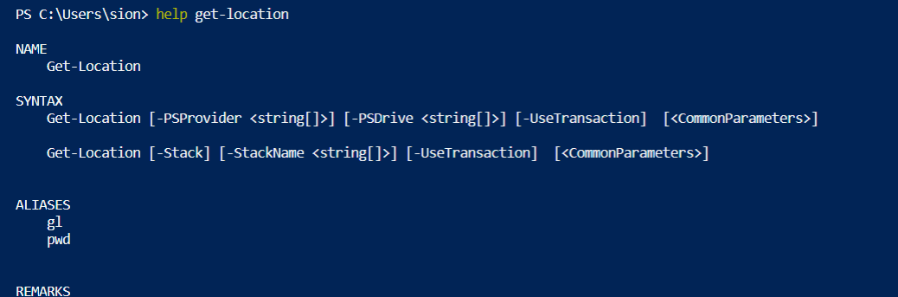

Alias
- Alias are shortcuts or alternate names for cmdlets. Use aliases when you do not want to type the verb-noun format. To get a list of aliases, type “get-alias” or “gal”. Notice that many UNIX commands (“ls”, “cd”, etc.) are set up as aliases by default.
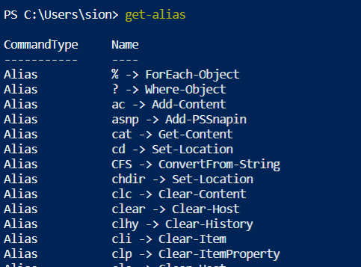

- To get a list of aliases that start with the letter c, type “gal c*”
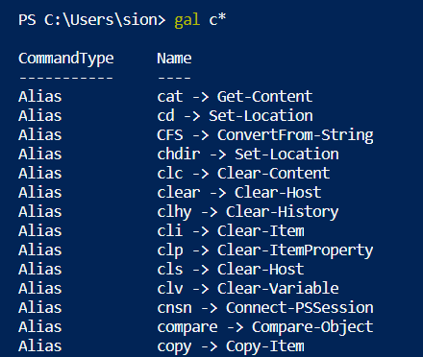

- You can use an alias, and it works the same as the cmdlet that it references. Type “Clear-Host” or “clear” or “cls”.


Mapping PSDrives
- PowerShell providers connect different forms of storage to PowerShell and make the forms of storage look like a file system. The providers provide access to data and components that would not be easily accessible at the command line. Type “get-psdrive” to see the list of providers.
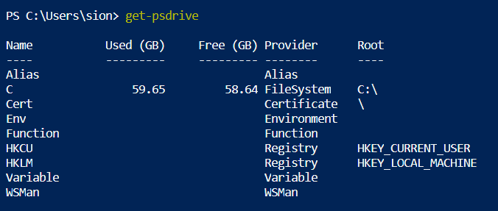

- To map a new drive, let’s start by creating a folder named ‘test’. Type “mkdir test”
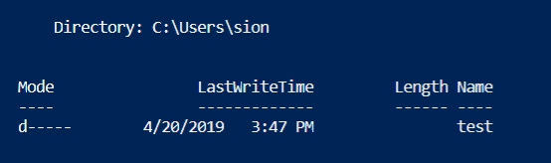

- To learn how to map a new drive, type “help new-psdrive”. 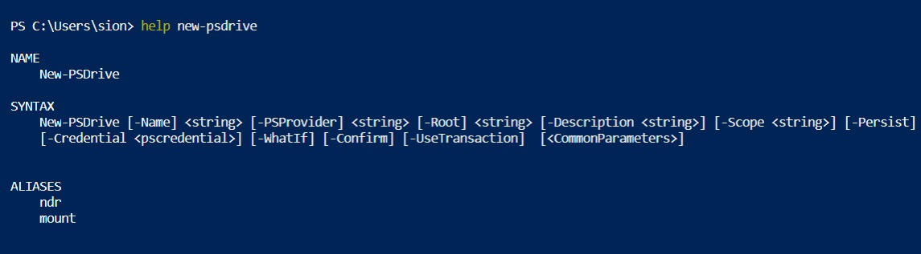

- If you look at the syntax, you will see that you can map a new drive by typing
“new-psdrive test filesystem c:\users\sion\test” for my case.
You will need to input your root path.
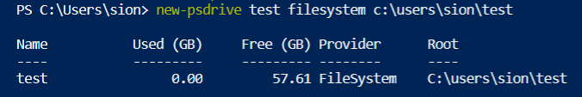
- To go the test drive that you just created, type “cd test:”
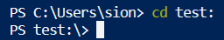
- Let’s go back to the psdrive to check if the new drive is there.
Type, “get-psdrive”.
Remember this is a psdrive and only exist within PowerShell.
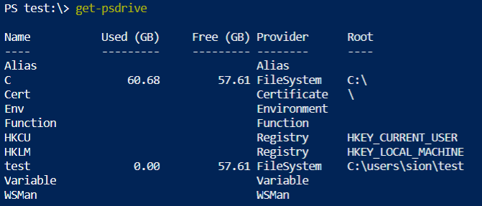

- Now if you go back to the c drive, type “cd c:”
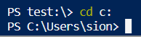

- Let’s now undo what we have done by typing “remove-psdrive test”

- Go back to your psdrive again to check if the drive has been removed
by typing “get-psdrive”
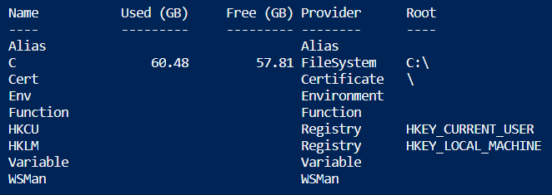

- Remove the test folder by typing “rmdir test”

Q&A
Justify your answers with at least one reference, then export this file to PDF version
- List out five cmdlets that you would use often and describe the function for each cmdlet.

- What would happen if you map a new PSDrive just as you have done in our activity and close your PowerShell session? Is the PSDrive persistent or non-persistent?
If non-persistent, what would you do to make it persistent?

PUSH YOUR WORK TO GITHUB

Once you completed the Hands-on practice, do the following to push your work to GitHub

Open the terminal from the VSCode by hitting the control + ~ key, make sure you are in the right path, for example: KimNguyen/Desktop/ISEC505/HOP02-KimNguyenMai/Module 2

Type the following command:

>>> git add . (to copy all changes you have made)
>>> git commit -m “Submission for Module 2 – YOUR GITHUB USERNAME” (To add a message to your submission)
>>> git push origin master (to upload your work to Github)

